Deepfake Face Detection



### Concept

**Deepfake** is a secure Android-based application designed to detect deepfake content (photos/videos) using AI-powered facial analysis. It includes face authentication for secure login, media upload, and instant real/fake classification using server-side models. The system helps individuals, journalists, and law enforcement verify the authenticity of visual media efficiently.



**Competitive Analysis**

**Problem Statement:**

Microsoft Video Authenticator:

Pros

* Uses AI for video deepfake detection

Cons

* Limited to enterprise/internal use; no Android version

Truepic:

Pros

* Offers secure camera with metadata verification

Cons

* Doesn’t offer deepfake classification for existing me

Amber Video:

Pros

* Real-time detection and labeling

Cons

* Only works on specific platforms; limited public accessibility

Current digital verification methods for media are fragmented and often require manual analysis or desktop tools. **Deepfake** automates the deepfake detection process on mobile devices, providing a fast, reliable, and easy-to-use platform for verifying the authenticity of faces in uploaded content.

## User Persona

Namc: PriyaSharma Age: 35

Occupation: Working Profcssional (Markcting Manager)

Location: Urban area, lives in a busy

metropolitan city Family: Married w'ith tw'o

kids (agcs 5 and 8)

**Solution:**

**Deepfake** allows Priya sharma and others to:Log in securely using face authentication.Upload images/videos.Get instant real/fake classification using deep learning models.Share verified results or alerts

via""WhatsApp/email

' "

B"u" siness Potential

Busness Potenhat0 oixth of hledVeuK flnesthesw 'Suite

World Market Indian Market

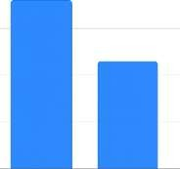40Po

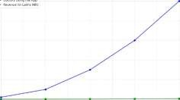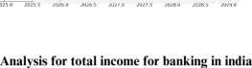

30B

20%





## User Flow Diagram

## Deepfake face Flow chart

↓

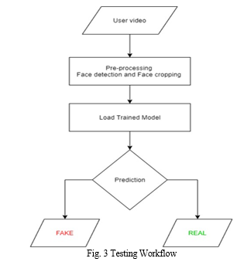

Week 1 2 3 4 5 6 7 8 9 10 13

Ideation

**Research **

Timeline

Design

**Development**



Testing

**Deployment**

Prototyping-Figma

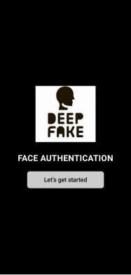

Result Screen

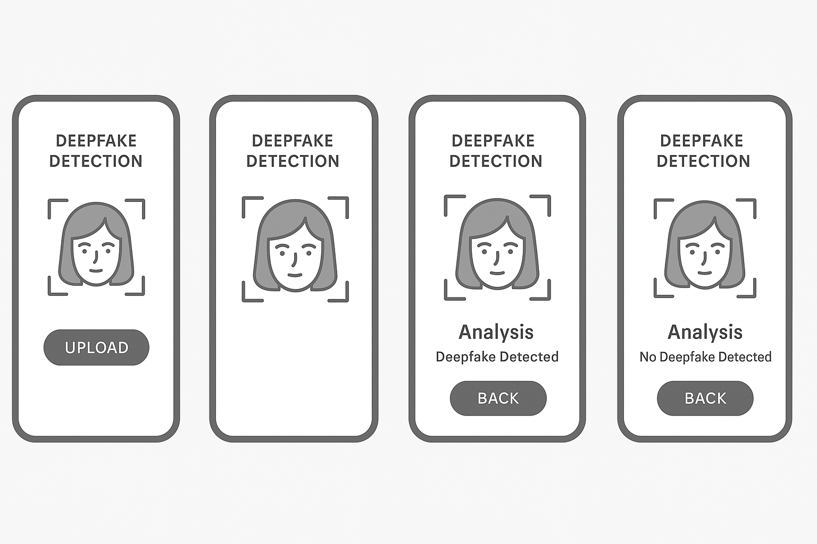Upload Screen



### 

Limitations

* + No QR-code media linking
  + No offline support
  + Not integrated with blockchain for evidence integrity
  + Only detects face-based deepfakes (not voice or text .

Application

* + Newsrooms: Validate video/image sources
  + Police/Forensics: Verify suspects' digital evidence
  + Social Media Teams: Prevent viral spread of fake content
  + Educational: Teach media literacy using real examples
  + Legal: Submit AI-verified evidence in court

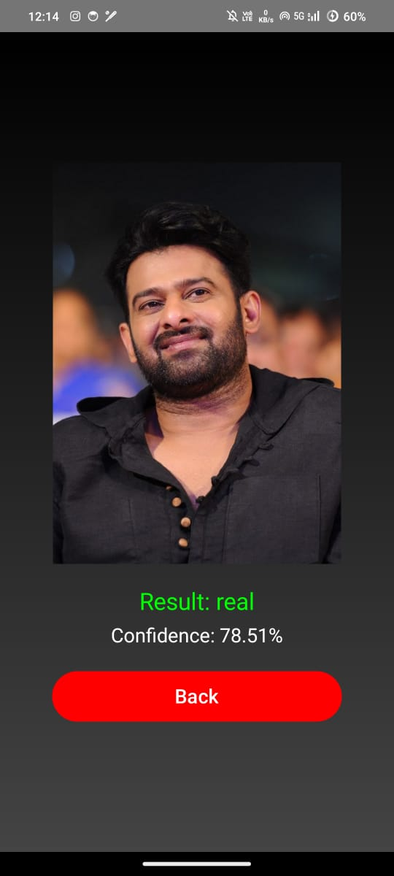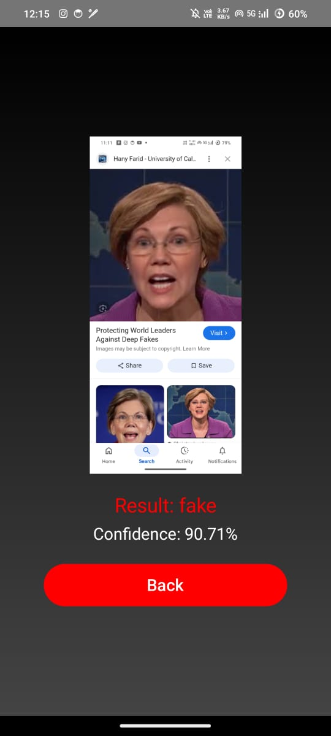







POTHULA VENKATA VISHNU VARDHAN

[pothulavenkatavishnuvardhan0520.sse@saveetha.com](mailto:pothulavenkatavishnuvardhan0520.sse@saveetha.com) Batch:2022-2026

192210520